Appendix S1. Detailed description of DCPPAgent as a local intelligent agent platform
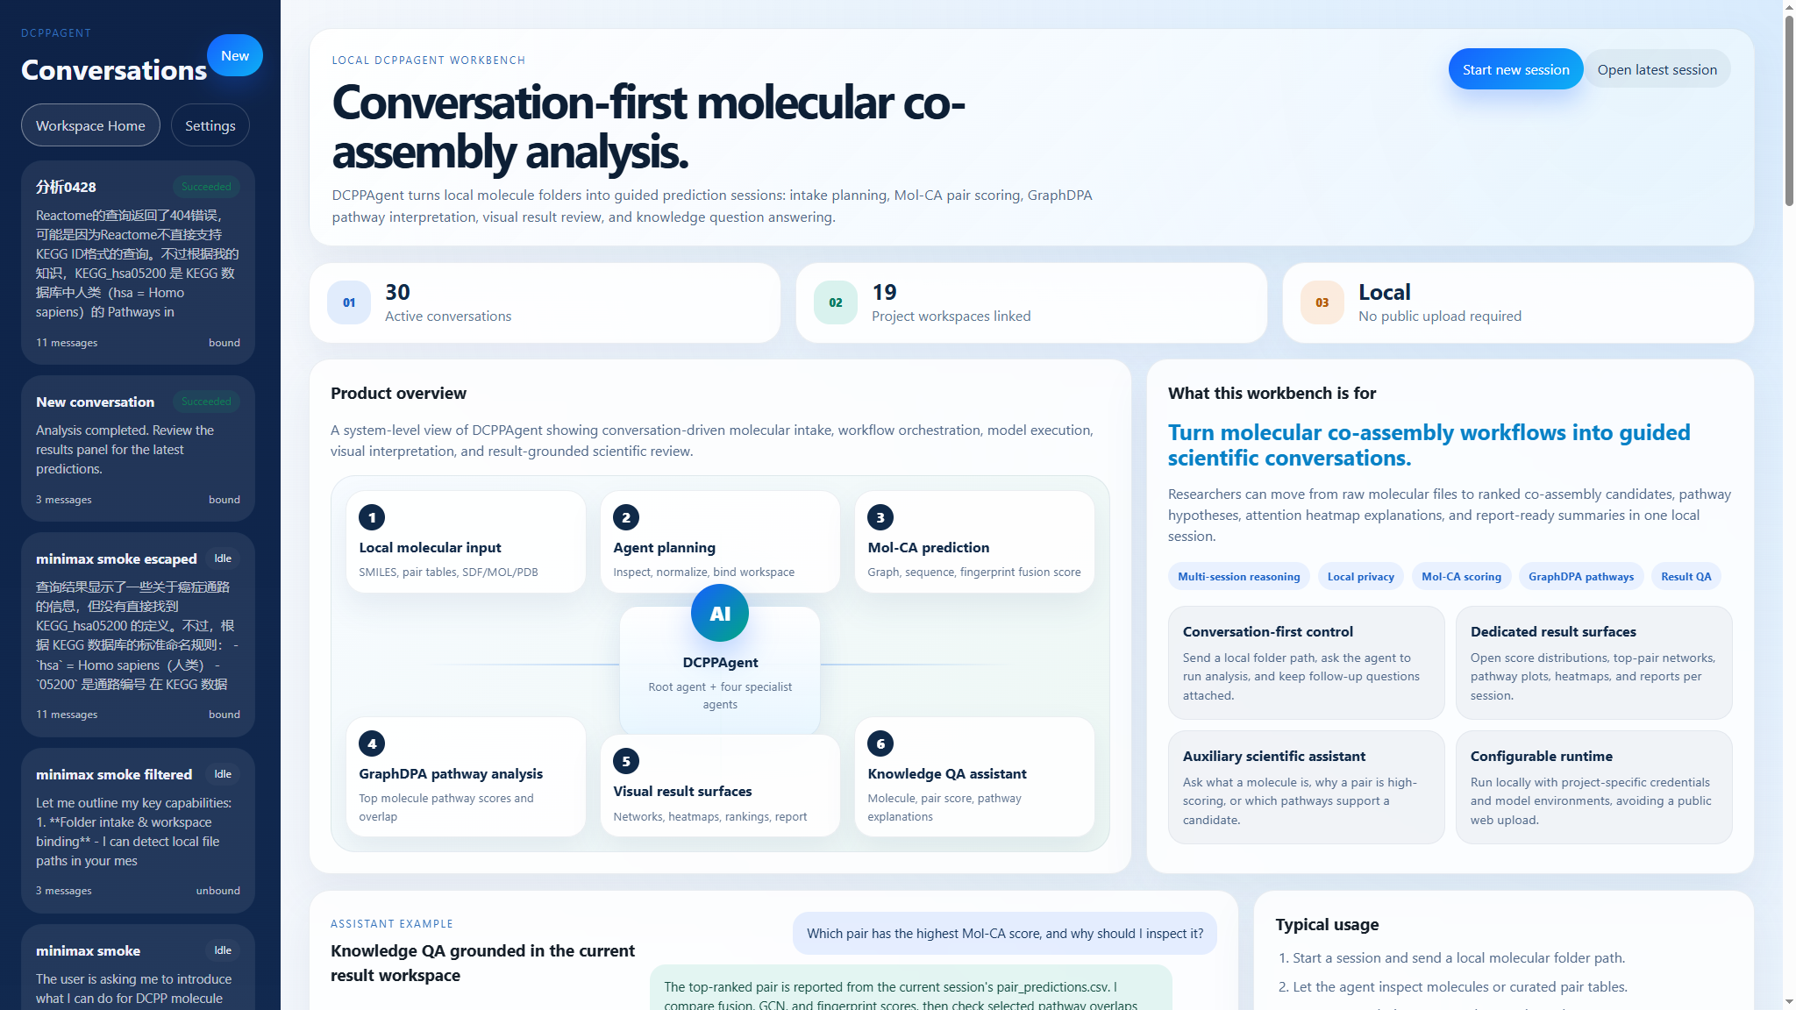
Fig. S0. DCPPAgent local workbench interface. The home page shows the conversation list, local workbench overview, agent-orchestrated Mol-CA and GraphDPA workflow, result surfaces, and knowledge QA assistant capability.
The screenshot demonstrates the intended local user interface of DCPPAgent. Similar to a scientific workbench, the left rail maintains conversation sessions, while the main panel introduces the local molecular input, agent planning, Mol-CA co-assembly prediction, GraphDPA pathway analysis, visual result surfaces, and knowledge question-answering assistant. This interface is designed for local deployment and avoids public upload of molecular structures or analysis results.
This appendix provides a detailed method-level description of DCPPAgent. The platform converts the original DCPP computational workflow into a local, session-based intelligent agent that can interpret user tasks, execute molecular co-assembly and pathway prediction models, organize visual outputs, and answer follow-up questions grounded in the generated results.

S1.1 Platform objective and design principle
DCPPAgent was developed to address the practical gap between a trained predictive model and routine use by researchers handling confidential molecular libraries. The design objective is not to replace Mol-CA or GraphDPA, but to wrap them in a reproducible local workflow that reduces manual file handling, prevents accidental public data submission, and keeps the analysis traceable from input files to final interpretation.
The platform follows three principles: local execution by default, deterministic model-tool invocation, and result-grounded natural-language interaction. Natural language is used for user interaction and explanation, whereas data normalization, prediction, aggregation, visualization, and report generation are performed by explicit software tools.

S1.2 Full DCPPAgent workflow
Workflow step | Explanation
1. User instruction and session creation | The user opens a local conversation and provides a folder path, molecular table, curated pair file, or analysis request. DCPPAgent creates or reuses one local workspace for that session.
2. Intake inspection | The intake and planning agent scans supported input files, detects molecular file formats, identifies table schemas, and determines whether the task is a molecule-set workflow or a curated pair-table workflow.
3. Molecule normalization | Supported molecules are converted to canonical SMILES when possible. Duplicate molecules are collapsed into a single molecular record while source-file provenance is retained.
4. Pair definition | For molecule-set input, all valid unordered molecular pairs are generated. For curated pair-table input, each MOL1-MOL2 row is preserved as the prediction unit; optional CLASS labels are stored only as metadata and are not used for inference.
5. Mol-CA co-assembly prediction | The prediction execution agent submits each pair to Mol-CA. The model computes graph, sequence, and fingerprint representations and returns a multimodal fusion score, with optional GCN and fingerprint auxiliary scores.
6. Top-pair selection | Pairs are ranked by fusion score. High-scoring candidates are selected for downstream pathway prediction and explanation according to the configured threshold or top-N fallback rule.
7. GraphDPA pathway prediction | GraphDPA predicts pathway associations for unique molecules appearing in selected high-scoring pairs. Molecule-level pathway scores are then aggregated into shared-pathway and union-pathway summaries for each pair.
8. Attention heatmap generation | For selected pairs, the GCN branch of Mol-CA is used to generate atom-level attribution weights. The weights are projected onto two-dimensional molecular depictions as attention heatmaps.
9. Visualization and report generation | The result workspace organizes score distributions, ranking tables, molecular networks, pathway plots, pair-pathway diagrams, attention heatmaps, and a markdown report.
10. Result-grounded question answering | The knowledge QA agent answers follow-up questions about molecules, pair scores, pathways, model interpretation, task status, and limitations by reading the current workspace results first and optional external knowledge second.

S1.3 Agent roles and information flow
The root agent coordinates the task and decides whether a message is a path-binding request, an execution request, a result-interpretation question, or a general knowledge question. The intake and planning agent handles file recognition and execution planning. The prediction execution agent invokes Mol-CA and GraphDPA through deterministic runners. The result interpretation agent summarizes quantitative outputs, high-scoring pairs, shared pathways, and limitations. The knowledge QA agent supports Chinese and English questions and prioritizes project-grounded evidence before external background knowledge.
The information flow is session -> workspace -> normalized molecules -> molecular pairs -> Mol-CA scores -> selected candidates -> GraphDPA pathway predictions -> visual summaries -> report -> result-grounded QA. Each stage writes intermediate files, which makes the final answer auditable and reproducible.

S1.4 Input modes and provenance
DCPPAgent supports two major prediction modes. In molecule-set mode, the input represents a list of individual compounds and DCPPAgent generates all valid pair combinations. In curated pair-table mode, each input row already defines a molecular pair, such as a table containing MOL1 and MOL2 columns; DCPPAgent predicts those rows directly without regenerating all-vs-all combinations. For both modes, the workspace stores source path, source row, molecule identifier, canonical SMILES, pair identifier, and prediction status.

S1.5 Result visualization examples from a local DCPPAgent run
The following figures were generated from actual local DCPPAgent output files in an example pair-table project. They are included to illustrate the result panel contents that can be used for manuscript figure design or supplementary documentation.
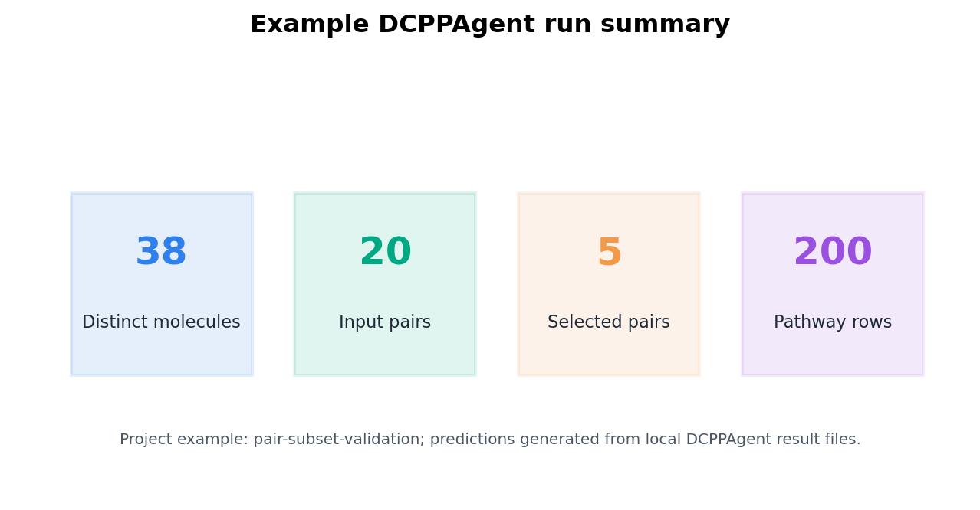
Fig. S1. Example local DCPPAgent run summary showing distinct molecules, input pairs, selected pairs, and pathway prediction rows.
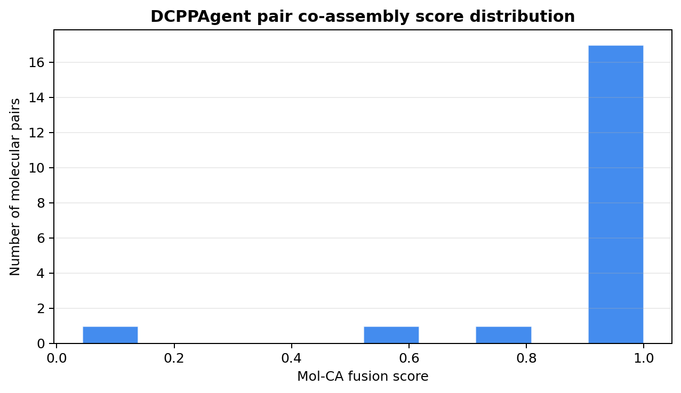
Fig. S2. Distribution of Mol-CA fusion co-assembly scores across input molecular pairs.
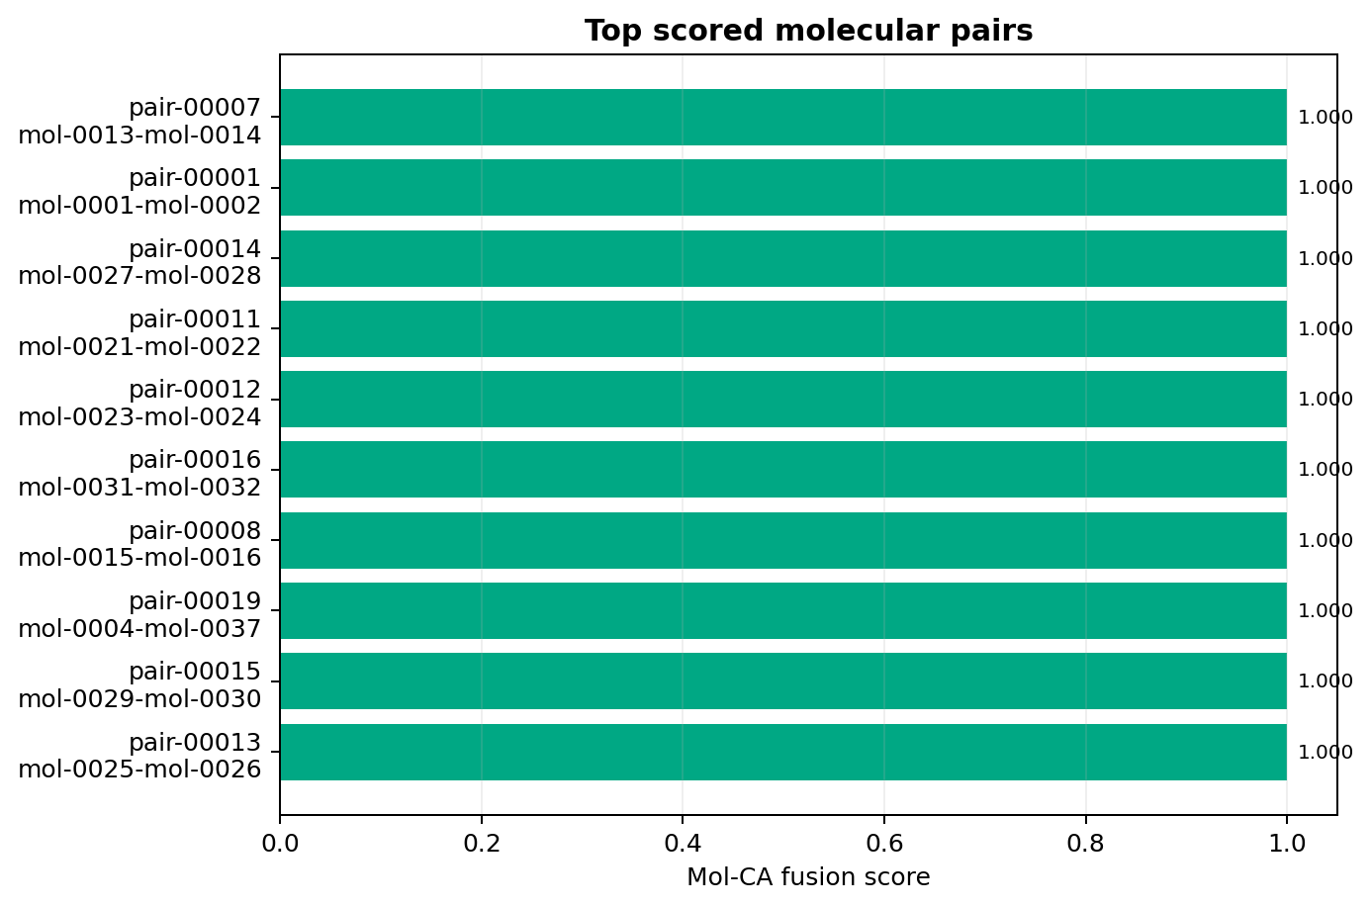
Fig. S3. Top molecular pairs ranked by Mol-CA fusion score.
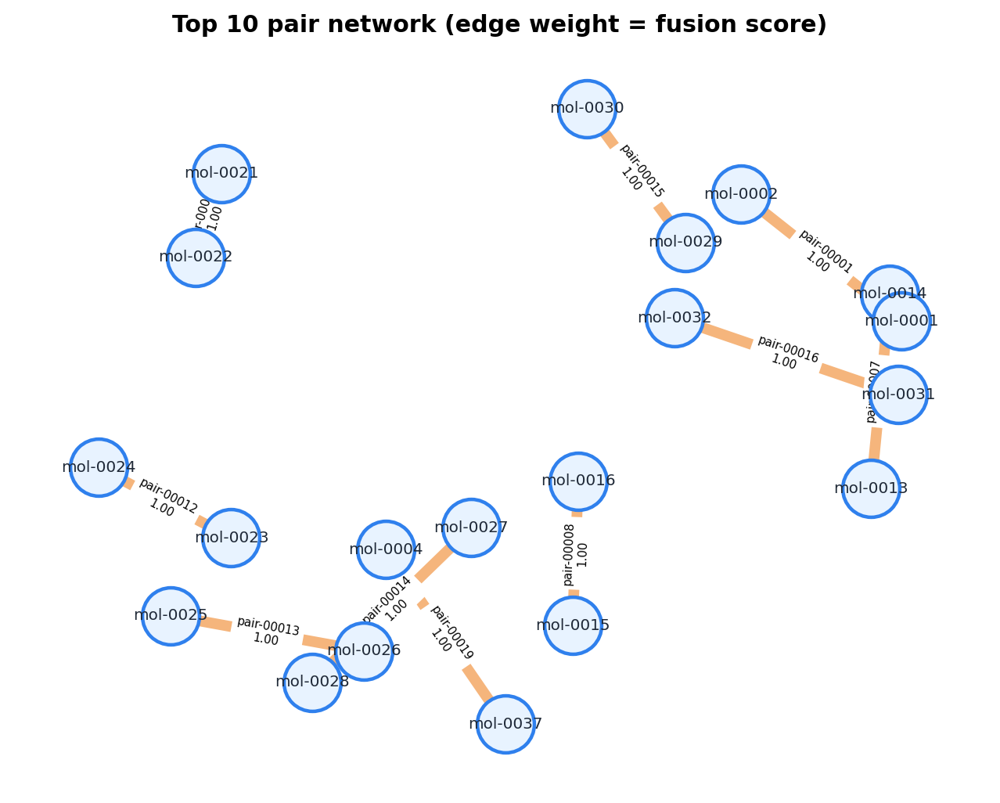
Fig. S4. Top-pair molecular network. Nodes represent molecules and edges represent high-scoring molecular pairs, with edge labels indicating pair identifiers and fusion scores.
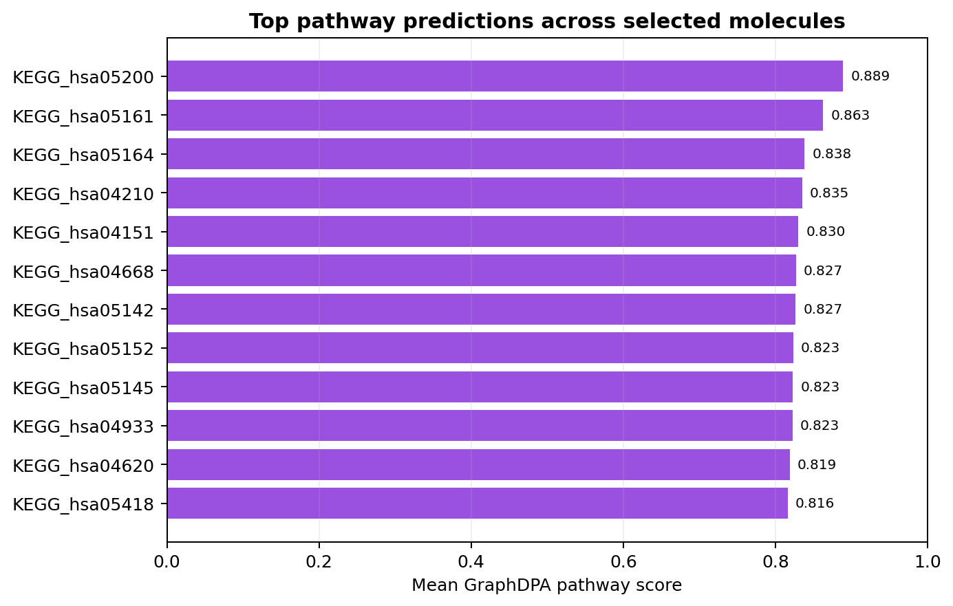
Fig. S5. Example top pathway predictions aggregated across selected molecules by GraphDPA score.
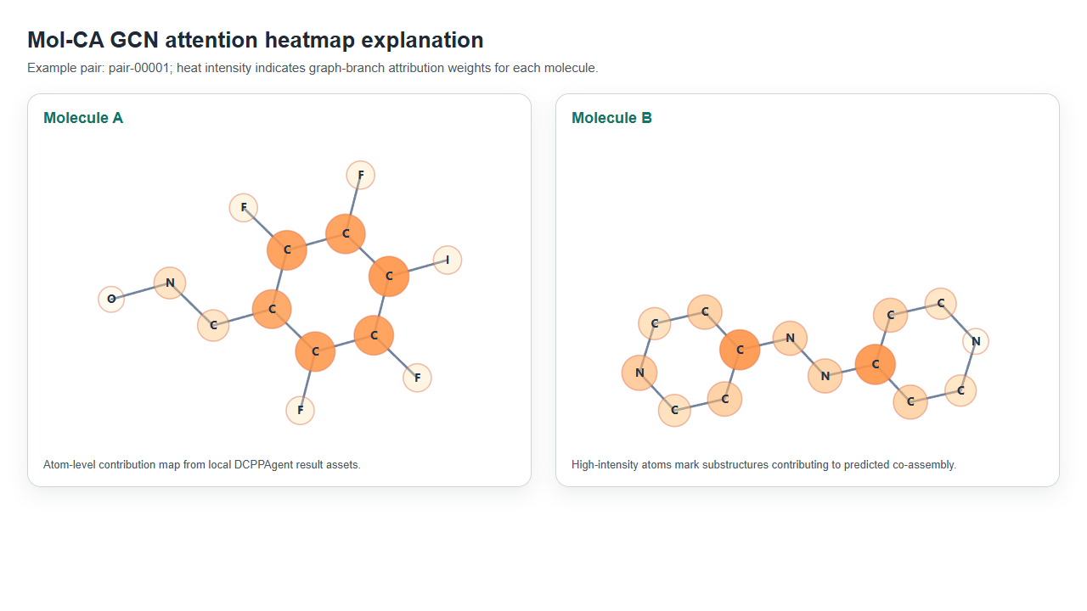
Fig. S6. Example Mol-CA GCN attention heatmap for a high-scoring pair. Heat intensity indicates graph-branch attribution weights projected onto two-dimensional molecular structures.

S1.6 Knowledge question answering after analysis
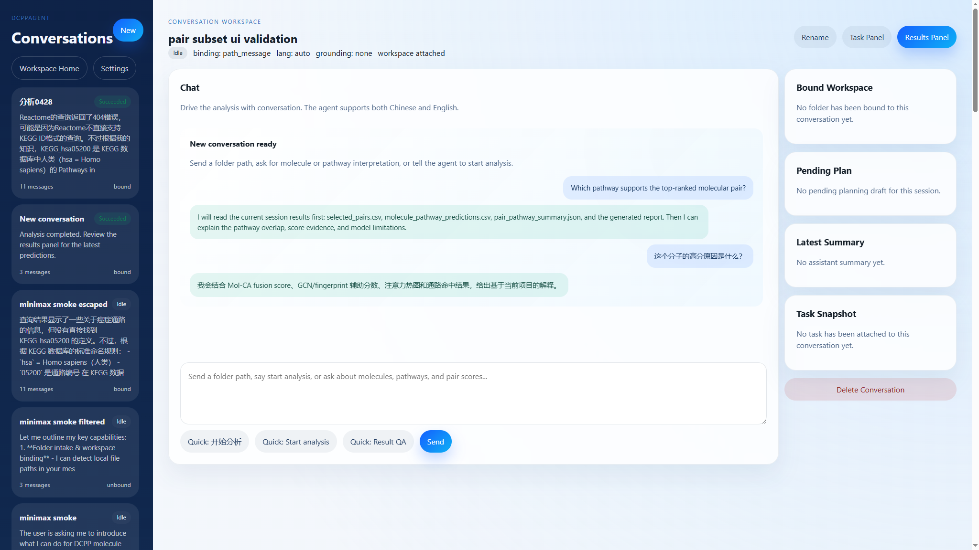
Fig. S7. Example knowledge question-answering assistant interface. The chat panel illustrates how DCPPAgent can answer result-centered questions about top molecular pairs, pathway support, score evidence, and attention heatmap interpretation in English or Chinese.
This assistant view is intended to support scientific review after model execution. Instead of giving generic background-only responses, the agent first grounds its answer in the active workspace, including pair_predictions.csv, selected_pairs.csv, molecule_pathway_predictions.csv, pair_pathway_summary.json, top_pair_explanations.json, and analysis_report.md. It then supplements the answer with external molecular or pathway knowledge only when the user asks for broader biological context.
After the prediction task is complete, users can ask questions such as:
Which pair has the highest co-assembly score?
Which molecules appear in the top-ranked pairs?
Which pathways are shared by a selected pair?
Why is this pair worth further validation?
What does a specific pathway represent?
The agent first reads local result files, including normalized_molecules.csv, pair_predictions.csv, selected_pairs.csv, molecule_pathway_predictions.csv, pair_pathway_summary.json, top_pair_explanations.json, and analysis_report.md. If the question asks for biological background beyond the project results, the agent can optionally supplement the answer with PubChem or Reactome knowledge.
The answer is therefore separated into two evidence layers: current-session facts and external background knowledge. Current-session facts include the actual model scores, ranks, pathway IDs, pair identifiers, and generated attention assets. External background knowledge is used only to contextualize those facts and should not override the model results.

S1.7 Interpretation of Mol-CA attention heatmaps
The attention heatmap is an attribution-style explanation for the GCN branch of Mol-CA. Atoms with stronger color intensity are assigned higher graph-branch weights and may represent substructures that contribute more strongly to the predicted co-assembly score. The heatmap should be interpreted as model evidence for feature contribution, not as direct experimental evidence of binding, intermolecular distance, or docking pose. For publication use, heatmaps are best presented together with fusion score, GCN score, fingerprint score, and downstream pathway context.

S1.8 Limitations and recommended reporting
DCPPAgent is intended for hypothesis generation and candidate prioritization. It does not remove the need for molecular dynamics simulation, physicochemical characterization, biological assays, or expert chemical review. Recommended reporting includes the input mode, number of valid molecules, number of input or generated pairs, Mol-CA score threshold or top-N rule, GraphDPA pathway catalog, selected pairs, top pathway predictions, and whether external knowledge sources were used for QA.

